MAJOR EQUIPMENT
Updated September 1, 2020

Major Equipment for Emory Multiplexed Immunoassay Core (EMIC) Users

EMORY MULTIPLEXED IMMUNOASSAY CORE (EMIC)
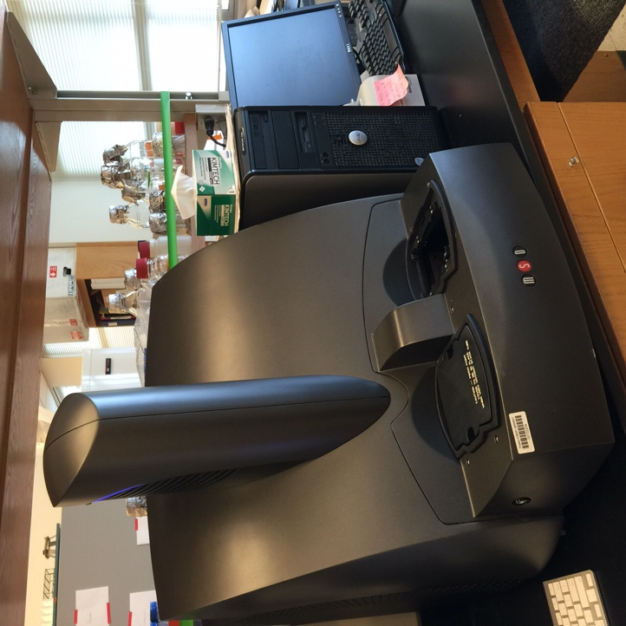
The Emory Multiplexed Immunoassay Core (EMIC), one of the Emory Integrated Core Facilities (EICF), houses two plate readers (SECTOR2400 and QuickPlex SQ120) to meet the needs of its users. These instruments require no customer calibration or maintenance, no complicated fluidics, and no between-read cleaning. The combination of rapid read times (90 seconds per plate) and the ability to perform multiple, simultaneous tests on a single sample increases productivity, conserves sample, and delivers results quickly. The MSD platform has a wide variety of commercially available assay kits and a full line of components and reagents for developing customized assays.
One high sensitivity imaging detection system SECTOR2400: provide unparalleled sensitivity and dynamic range, simple protocols, rapid and continuous reads, and fast, well-organized results via DISCOVERY WORKBENCH assay analysis software.
One high sensitivity imaging detection system MESO QuickPlex SQ 120: provide unparalleled sensitivity and dynamic range, simple protocols, rapid and continuous reads, and fast, well-organized results via DISCOVERY WORKBENCH assay analysis software.

