Facilities & Other Resources
Updated: August 17th, 2022

Fields Relevant for the Emory Stem Cell Core (ESCC) Users

Other:

EMORY STEM CELL CORE (ESCC)
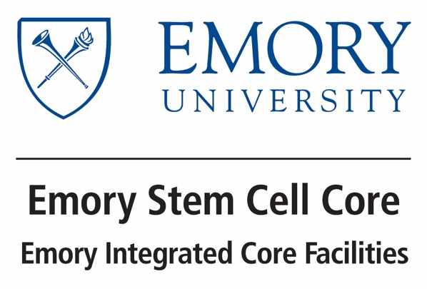
The Emory Stem Cell Core (ESCC), one of the Emory Integrated Core Facilities (EICF), brings a powerful research platform of generating patient specific stem cells and neural progenitor cells in support of Emory investigators. The ESCC’s focus and technical expertise is to derive and characterize human induced pluripotent stem cells (iPSCs) from terminally differentiated somatic cells using non-integrating methods. IPSCs generated from patients with a genetic defect allows for a unique opportunity to study the mechanisms of disease in an in vitro model. Other applications for these cells include CRISPR gene editing the cell lines, developing a reporter line, drug screening and discovery, and potentially regenerative therapies. Additionally, the core will provide training and educational resources to support investigators with interest in human stem cells. The ESCC interfaces with other members of the Emory Integrated Core Facilities as a pipeline to analyze patient cells that will inform drug discovery and personalized medicine.
The ESCC uses human cells, whole blood, urine and skin samples, as provided by investigators with IRB approval, as source material for the derivation of an induced pluripotent stem cell (iPSC) line. The ESCC is able to isolate primary fibroblasts from skin tissue and acquire a variety subtypes of blood cells from whole blood. Patient iPSC-derived neural progenitor cells, microglia and brain cortical organoids can also be generated by the core.
The ESCC located in a laboratory located on the 4th floor of the Whitehead Biomedical Research Building, with approximately 500 square feet of dedicated cell culture and wet-lab space. The ESCC’s cell culture room includes three biosafety cabinets, five carbon-dioxide incubators, three EVOS microscopes, a Countess cell counter, a Neon transfection system, a PCR machine and three orbital shakers. The ESCC also houses its own LS6000 liquid nitrogen dewar with a CS100 controller for automatic level control for storage of cryopreserved cells during active projects. The ESCC has additional access to a Nikon Eclipse TI Fluorescence Microscope, a Nikon Biostation IM Microscope, a Keyence Fluorescence Microscope, an Applied Biosystems QuantiStudio 6 Flex Real Time PCR machine, a Biorad ChemiDoc MP Imaging system and a Synergy H1 Multi-mode Plate Reader.

