EMORY INTEGRATED MICROBIOME CORE FACILITIES

The Emory Integrated Microbiome Core Facilities represent a synergistic collaboration among three specialized core facilities: the Emory Gnotobiotic Animal Core (EGAC), the Emory Integrated Genomics Core (EIGC), and the Emory Integrated Computational Core (EICC). Together, these cores form a streamlined and integrated pipeline for microbiome research. Gnotobiotic studies are conducted within the EGAC, followed by microbiome sequencing performed by the EIGC. The resulting sequence data are then analyzed by the EICC, which provides expert computational analysis, including the characterization of microbial alpha and beta diversity. This coordinated workflow ensures high-quality, reproducible data and supports a wide range of microbiome-focused research projects.

The Emory Gnotobiotic Animal Core (EGAC)
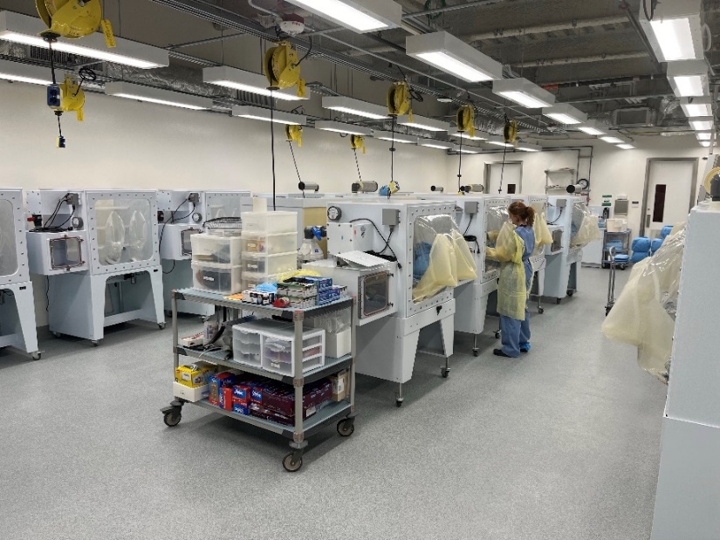
Introduction: The Emory Gnotobiotic Animal Facility Core is housed within the newly constructed, five-story, 200,000-square-foot Health Sciences Research Building (HSRB). Strategically located adjacent to the Specific Pathogen-Free (SPF) murine housing and the Transgenic Mouse and Gene Targeting Core, the facility is ideally positioned to support advanced microbiome and host–microbe interaction studies.
The facility is equipped with twenty 3-foot-wide rigid isolators (Parkbio), each capable of housing up to 12 mouse cages, with a maximum of five mice per cage. This setup allows for the controlled maintenance of germ-free and gnotobiotic mouse colonies under sterile conditions. In addition, Class II biological safety cabinets are available for investigators to perform experimental procedures in a sterile and safe environment.
Emory Gnotobiotic Animal Core (EGAC) main vivarium

Animal welfare: The Emory Gnotobiotic Animal Facility Core is committed to the highest standards of animal care and welfare. A dedicated technician is responsible for daily monitoring of murine health and well-being. All animal care and use within the facility are conducted in accordance with Emory University’s Institutional Animal Care and Use Committee (IACUC)-approved Standard Operating Procedures (SOPs), ensuring ethical and humane treatment of animals. IACUC oversight is maintained through rigorous processes, including the submission and review of detailed animal use protocols by committee members. Additionally, the facility undergoes semiannual inspections of all areas where animals are housed or where procedures are performed. These evaluations are guided by federal regulations, veterinary standards of care, institutional policies, and facility-specific SOPs. This comprehensive oversight ensures that all research conducted within the facility adheres to the highest ethical and regulatory standards.

Microbiological Testing: To maintain the integrity of germ-free conditions, the Emory Gnotobiotic Animal Facility Core employs rigorous microbiological testing protocols for all materials introduced into isolators, including food, water, and bedding. In addition, germ-free mice housed within isolators are routinely monitored through periodic control necropsies and microbial screening. Our comprehensive testing strategy includes:
- Real-Time Quantitative PCR (qPCR): Amplification of the V4 region of the 16S rRNA gene to detect bacterial DNA with high sensitivity and specificity.
- Culture-Based Testing: Plating of fecal samples on BBL Brain Heart Infusion (BHI) agar supplemented with 10% sheep blood, a non-selective medium that supports the growth of a broad range of bacterial species. Plates are incubated at 37°C for 7 days.
- Thioglycollate Broth Incubation: Use of thioglycollate medium with an indicator to support the growth of aerobes, anaerobes, and microaerophiles that are not excessively fastidious.
- Gram Staining: Microscopic examination of fecal or tissue samples to visually assess the presence and morphology of bacteria, distinguishing between Gram-positive and Gram-negative organisms.
These layered testing approaches ensure the sterility of isolator environments and the validity of gnotobiotic experiments.

Gnotobiotic Colonization: For colonization studies, 5-week-old germ-free mice are inoculated using one of the following approaches:
- Mono-Colonization: Introduction of a single bacterial species to study its isolated effects on host physiology and immune responses.
- Defined Microbial Communities: A commonly used model is the Altered Schaedler Flora (ASF), a standardized consortium of eight bacterial species. ASF includes two Lactobacillus species, one Bacteroides, one spiral bacterium from the Flexistipes genus, and four extremely oxygen-sensitive Fusobacterium species. These microbes are selected for their dominance and persistence in the murine gut and their ability to be cultured in laboratory settings. ASF-colonized mice exhibit normal gastrointestinal function, a fully developed immune system, and resistance to opportunistic pathogens, making them a robust model for studying host–microbe interactions and disease mechanisms.
- Polymicrobial Colonization: Introduction of complex microbial communities derived from donor mice or human clinical samples. For example, microbiota from antibiotic-treated individuals can be used to investigate how altered microbial diversity influences host physiology and disease susceptibility.
Inoculation Methods:
- Microbes are typically introduced via oral gavage using a 24-gauge ball-tipped needle.
- Alternatively, due to the coprophagic behavior of mice, fecal microbiota transfer can be achieved by placing donor fecal pellets into the recipient cage.
Microbiome Monitoring: To ensure the stability and fidelity of colonization, routine microbiological testing is performed throughout the experiment. This includes:
- Collection of stool samples
- DNA extraction
- PCR amplification of the V4 region of the 16S rRNA gene
- Sequencing of PCR products
- Bioinformatic analysis using QIIME and MOTHUR pipelines to assess microbial diversity and composition

Facility Capabilities: In addition to traditional isolator-based housing, the facility is equipped with the Tecniplast ISOcage system, which allows for gnotobiotic isolation at the single-cage level. This system supports up to 36 individually housed studies on a single rack, enabling high-throughput and parallel experimentation.

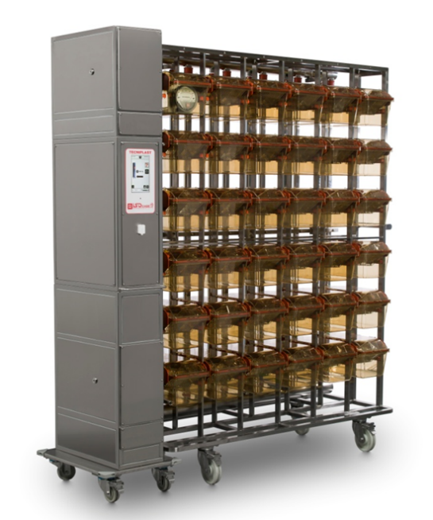
ISOcage Tecniplast Bioexclusion System
Precise modulation of the microbiome is increasingly recognized as a powerful strategy to influence health and disease. However, microbiome heterogeneity across murine colonies housed in different facilities presents a significant challenge to scientific rigor and reproducibility. Notably, inconsistent results have been observed when mice of the same genotype are subjected to identical assays in different institutions, largely due to variations in microbial composition.
To address this, we have established a dedicated facility designed to minimize microbiome-driven variability by conducting experiments in mice colonized with defined microbial communities under gnotobiotic conditions. Central to this effort is our use of the Tecniplast ISOcageP Bioexclusion System—a state-of-the-art platform for germ-free and gnotobiotic research.
The ISOcageP system consists of airtight, individually ventilated cages maintained under high positive pressure, specifically engineered for bioexclusion and microbiome-controlled studies. Unlike traditional multi-cage gnotobiotic isolators, which typically support only one study at a time, the ISOcageP system enables up to 36 simultaneous gnotobiotic experiments on a single rack. This scalability significantly enhances experimental throughput and flexibility.
ISOcage Tecniplast Bioexclusion system
In our workflow, mice are initially raised under germ-free conditions. At weaning (approximately 3 weeks of age), they are transferred into individual ISOcages for colonization and experimental manipulation. This system allows for precise control of microbial exposure while maintaining strict bioexclusion standards, thereby supporting reproducible and high-fidelity microbiome research.
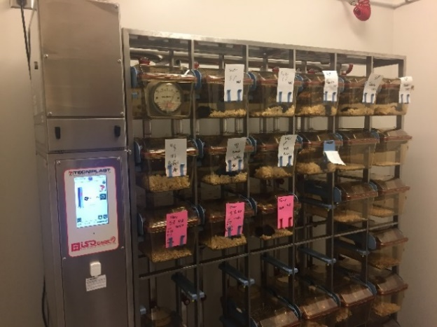
ASF Colonization and Fecal Microbiota Transplantation
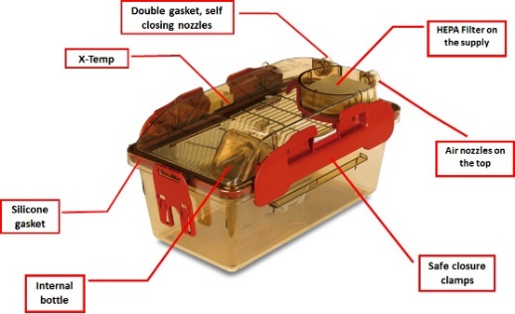
For experiments requiring a fully characterized and controlled microbiome background, mice may be colonized with the Altered Schaedler Flora (ASF)—a standardized consortium of eight bacterial species. ASF enables highly controlled studies in a defined microbial context. Compared to germ-free animals, ASF-colonized mice exhibit normal immune system development, resistance to opportunistic pathogens, and healthy gastrointestinal function. As such, they serve as an excellent model for studying host–microbe interactions in a reproducible and physiologically relevant setting. ASF colonization is initiated by the purchase of ASF-containing fecal pellets from Taconic Biosciences Inc., a commercial supplier of gnotobiotic materials. Colonized mice are maintained in the Tecniplast ISOcageP Bioexclusion System and, for probiotic supplementation studies, are fed the probiotic formulation twice weekly. This setup ensures a consistent microbial background and minimizes environmental contamination, thereby enhancing scientific reproducibility. For fecal microbiota transplantation (FMT) experiments, luminal contents from human donors will be used to colonize germ-free mice. Following transplantation, mice will be housed in the ISOcageP system for the duration of the study (up to 8 weeks) to maintain strict bioexclusion conditions. This approach prevents the introduction of unintended microbial species and preserves the integrity of the transplanted microbiome throughout the experimental period.
ISOcage Tecniplast Bioexclusion system

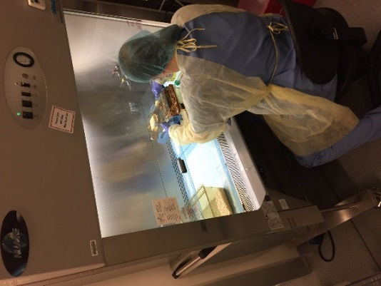
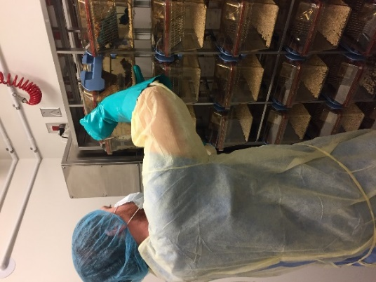
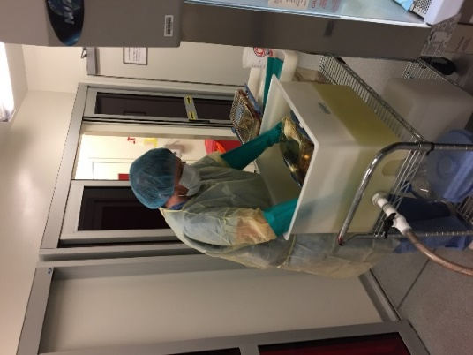

Murine Strains and Housing Capabilities: The Emory Gnotobiotic Animal Facility Core maintains two large breeding colonies of C57BL/6J mice, which serve as the foundational strain for many gnotobiotic and microbiome studies. These colonies are bred and housed under germ-free conditions to ensure consistency and microbiological integrity.

Introduction of New Strains: To support diverse research needs, the facility accepts rederived germ-free mice from approved vendors, including (but not limited to) Taconic Biosciences and the National Gnotobiotic Animal Resource Center at the University of North Carolina (UNC). All incoming mice must be shipped in certified germ-free transport containers. Upon arrival, mice are transferred into newly prepared isolators and housed as the sole genotype within that isolator for a minimum of four weeks, during which they are monitored weekly for germ-free status using standard microbiological testing protocols.

Dedicated Barrier Suite for Human Microbiome-Associated (HMA) Mice: For studies involving human microbiome-associated (HMA) mice, a dedicated gnotobiotic barrier access suite is available. These mice are generated and maintained under strictly controlled conditions to preserve the integrity of the transplanted human microbiota. Both germ-free and HMA mice used in experimental manipulations are housed within the Tecniplast ISOcageP Bioexclusion System. These hermetically sealed cages prevent microbial drift and ensure the stability of the microbiome throughout the duration of the study.

