**Use InnoScan AL1100 Scanner to Scan Microarray Slide**

**General Procedure:**

***Scan slides:***

1. Turn on scanner, open Mapix software, select the “Connect to Scanner” button and wait for the laser to warm up for at least 5 min.
2. Insert dry slide into the slide loader, click the “Insert” button and the scanner detects how many slides are loaded and corresponding position. Select the slides you want to scan.
3. Set scan configuration. Below parameters are standard settings used by our core.

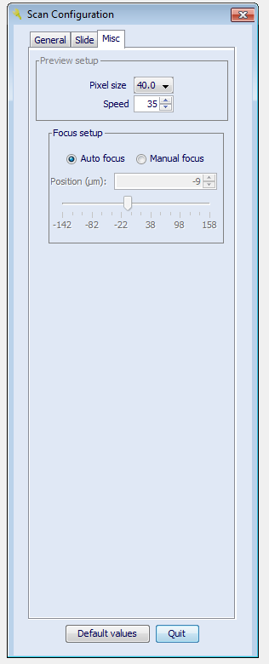

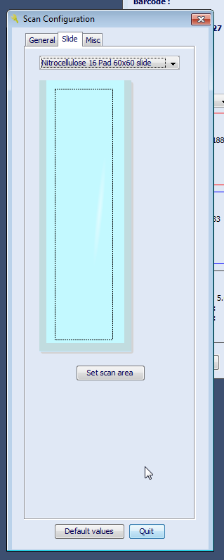

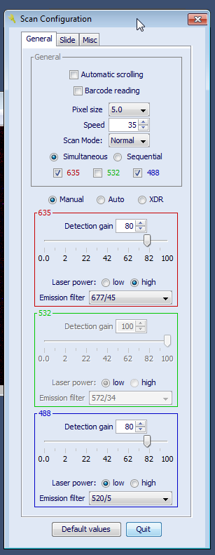

1. Click the “Scan” button and the software promotes to ask where to save the images. Choose the appropriate folder and enter file name. Scanned image is saved automatically as a TIF file. Below options are our standard settings:
2. Use TIFF LZW compression (lossless);
3. Prefix file name: Date & Time.
4. After scanning is done, click the “Disconnect to Scanner” button and turn off the scanner power.

***Fluorescent Signals Acquisition and Data Analysis***

1. When quantifying the fluorescent signals, open the image TIF file in Mapix software.
2. Load the Grid file (or GAL file), align the spots using automatic find function, and then manually align blocks and spots.
3. Set Algorithms parameters as shown below.

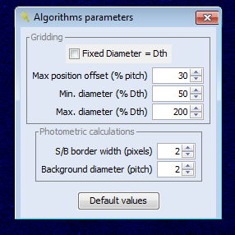

1. Save result with the following options:

1) All blocks in a file;

2) Save a JPEG file;

3) Integer value.

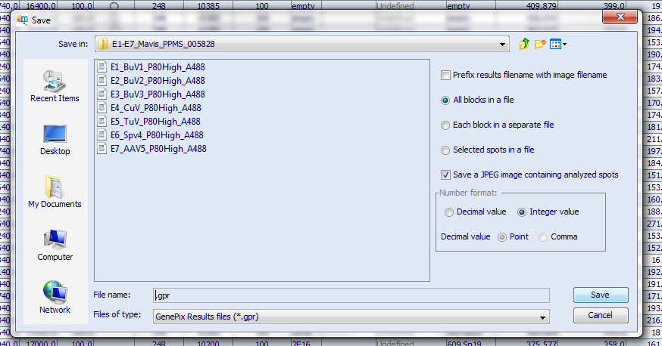

1. A raw data file containing quantified fluorescent signal is a file with .gpr extension and it is a txt file. Use Microsoft excel to open it and process the data. Alternatively, import them to other data analysis software such as R to do the downstream data summary.