MAJOR EQUIPMENT

Updated 1 September 2020

Major Equipment for Emory Integrated Metabolomics and Lipidomics Core (EIMLC) Users

EMORY INTEGRATED METABOLOMICS AND LIPIDOMICS CORE (EIMLC)
The Emory Integrated Metabolomics and Lipidomics Core (EIMLC), one of the Emory Integrated Core Facilities (EICF), performs quantitative metabolomics and lipidomics analyses on samples from a wide variety of biological matrices (e.g. blood, serum, plasma, solid tissues, cell extracts, etc.) to support both clinical and basic research efforts on campus and in the broader research community. Major equipment available in the EIMLC includes:
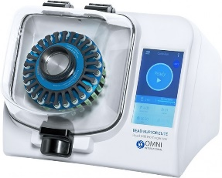
Sample Preparation:
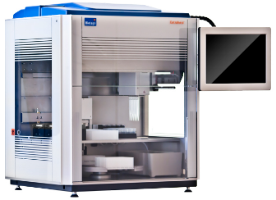
Omni BeadRuptor: Sample preparation instrument used to grind, lyse, and homogenize samples. This automated, bead mill homogenizer is able to prepare biological samples, including brain, liver, heart, skeletal muscle, adipose, as well as cell culture for lipid or metabolite extraction.
Biotage Extrahera Solid Phase Extraction Robot: This instrument is a robust and automated liquid handling instrument that performs solid phase liquid extractions in both single cassette and 96-well plate formats.
Chromatography:
Sciex Exion LC U/HPLC: Front end liquid chromatography instrument with dual pumping system capable of gradients up to 3ml/min at 6600 bar (9500 PSI). Instrument contains a cooled autosampler that accommodates two 96 well plates or 105 vials. Used in combination with Sciex Qtrap5500.
1290 Infinity II HPLC: Powerful front end liquid chromatography system capable of 1300bar pressures at 5ml/min. Contains a binary pumping system and chilled autosampler. Used in tandem with Agilent 6495c.
Thermo Vanquish UPLC: High end UHPLC instrument capable of pressures up to 1500 bar at flow rates of 5ml/min. System contains a binary pump and refrigerated autosampler with excellent precision, accuracy, and short cycle times. For use with Thermo IDX hybrid mass spectrometer.
Mass Spectrometers:
Sciex QTrap 5500: Hybrid mass spectrometer with triple quadrupole and linear ion trap, capable of MSn experiments. Instrument has a mass range of m/z 5-1250 and a dynamic range of up to 6 orders of magnitude. Used for targeted lipidomics experiments.
Agilent 6495c: Advanced, high sensitivity triple quadrupole mass spectrometer with jet ion source permitting 5x more ionization than traditional sources, increasing analytical sensitivity. Mass range of m/z 5-3000 and wide dynamic range. Used for MRM based targeted lipidomics experiments.

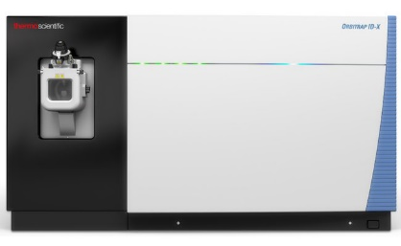
Thermo ID-X Tribrid: Hybrid Orbitrap mass spectrometer offering resolution up to 500,000 FWHM in mass range of m/z 50-2000. Contains a linear ion trap capable of MSn scans at 40Hz. Used for ultra high resolution untargeted, global lipidomics as well as metabolomics.
Software:
Analyst 1.5: Used for the operation of QTrap5500 mass spectrometer and collection and processing of targeted lipidomics data.
LipidView: Software used for the identification of lipids in biological samples by searching parent and fragment ion masses to a proprietary database containing over 25,000 lipids in a wide variety of lipid classes.
MultiQuant: Modular software used for processing MRM based datasets. Uses algorithms optimized for the automated integration of peaks with low signal to noise ratios.
MassHunter: Software used for the operation and analysis of mass spectrometry data collected on the Agilent 6495c.
Excalibur: Used for the operation of Thermo IDX mass spectrometer. Contains modules for the processing and analysis of mass spectrometry data.
LipidSearch: Lipid identification software that searching fragment ion data against a proprietary database to streamline identification of lipid species and visualization of data.
Compound Discoverer: Software that streamlines identification of small molecules by searching full scan and MSn data with known compounds and molecular pathways.

