FACILITIES & OTHER RESOURCES

Updated: September 1, 2020

Specific Fields Relevant for Emory Cellular and Immunotherapy Core (ExCITE) Users

Other:

EMORY CELLULAR AND IMMUNOTHERAPY CORE (ExCITE)
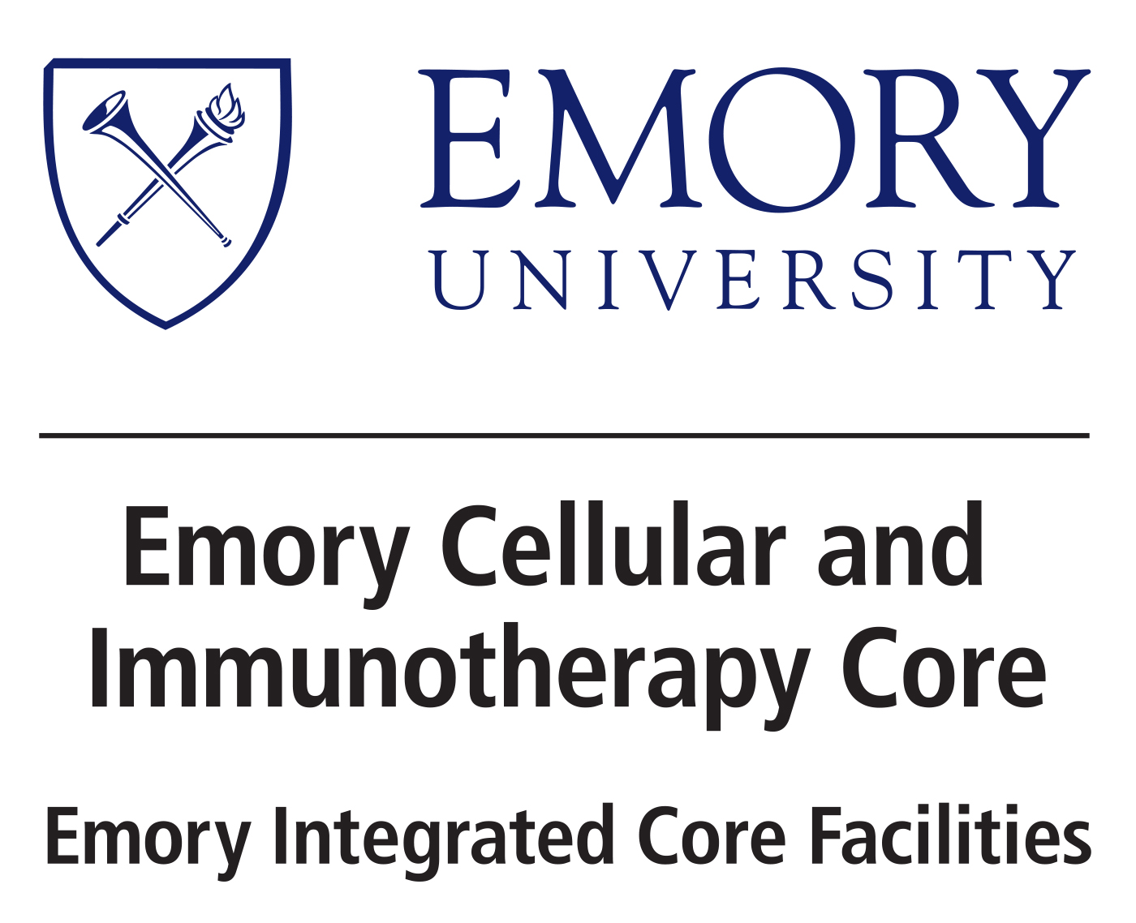
The Emory Cellular and Immunotherapy Core (ExCITE), one of the Emory Integrated Core Facilities (EICF), is a clinical cell manufacturing facility that prepares cell and immunotherapy products for transplantation and GMP-grade cells and reagents. The central mission of the is to provide GMP-compliant cell manufacturing and consulting for the translational of Emory-based research into early phase clinical trials. The types of products routinely handled in ExCITE include autologous and allogeneic bone marrow, peripheral blood hematopoietic cell products from mobilized donors, non-mobilized apheresis products, expired platelet units for the preparation of GMP-grade platelet lysate and cellular products from external companies. Standard processes performed by EPIC include isolation, expansion, cryopreservation and thaw of Mesenchymal stem/stromal cells, dendritic cells and other cellular products from FDA-approved studies. EPIC is also responsible for CD34+ enrichment and specific cell depletion using CliniMACS technology regulated by the FDA under Investigational New Drugs/Investigational Device Exemptions (IND/IDE).
The ExCITE is accredited by the Foundation for the Accreditation of Cellular Therapy (FACT) for more than minimally manipulated cellular therapy products. Two laminar flow hoods (Nuaire) and 6 CO2 incubators are also located within the space. The infrastructure includes equipment necessary for cell processing including a Cobe 2991 cell washer, a centrifuge, a light microscope and phase microscope, rocking platforms, digital vortex mixer and sealers. The ExCITE has a computer for operations inside the clean room. Individual members of the ExCITE also have personal workstations that support their core activities. The ExCITE has dedicated office on the same floor to the laboratory space on the 6th floor of the University Hospital, which provides for computational services, meeting customers, and weekly EPIC team meetings.

